

**VIVEKANANDA INSTITUTE OF PROFESSIONAL STUDIES - TECHNICAL CAMPUS**

**Grade A++ Accredited Institution by NAAC**

NBA Accredited for MCA Programme; Recognized under Section 2(f) by UGC;

Affiliated to GGSIP University, Delhi; Recognized by Bar Council of India and AICTE

An ISO 9001:2015 Certified Institution

**SCHOOL OF ENGINEERING & TECHNOLOGY**

**B. Tech Programme: AI-ML (A) (4th Semester)**

**Course Title: Fundamentals of Machine Learning Lab**

**Course Code: AIML - 258**

**Submitted To: Submitted By:**

**Dr. Shalini Gambhir Name: Kunsh Sabharwal**

**Enrolment No: 01117711623**

**VIVEKANANDA INSTITUTE OF PROFESSIONAL STUDIES - TECHNICAL CAMPUS**

**Grade A++ Accredited Institution by NAAC**

NBA Accredited for MCA Programme; Recognized under Section 2(f) by UGC;

Affiliated to GGSIP University, Delhi; Recognized by Bar Council of India and AICTE

An ISO 9001:2015 Certified Institution

**SCHOOL OF ENGINEERING & TECHNOLOGY**

**VISION OF INSTITUTE**

To be an educational institute that empowers the field of engineering to build a sustainable future by providing quality education with innovative practices that supports people, planet and profit.

**MISSION OF INSTITUTE**

To groom the future engineers by providing value-based education and awakening students' curiosity, nurturing creativity and building  
capabilities to enable them to make significant contributions to the world.

**VIVEKANANDA INSTITUTE OF PROFESSIONAL STUDIES - TECHNICAL CAMPUS**

**Grade A++ Accredited Institution by NAAC**

NBA Accredited for MCA Programme; Recognized under Section 2(f) by UGC;

Affiliated to GGSIP University, Delhi; Recognized by Bar Council of India and AICTE

An ISO 9001:2015 Certified Institution

**SCHOOL OF ENGINEERING & TECHNOLOGY**

**INDEX**

|  |  |  |  |  |  |  |  |  |
| --- | --- | --- | --- | --- | --- | --- | --- | --- |
| S.No. | Experiment | Date | Marks | | | Remarks | Updated Marks | Faculty Signature |
| Laboratory Assessment (15 Marks) | Class Participation (5 Marks) | Viva (5 Marks) |  |  |  |
| 1. | Study & Implement Linear Regression |  |  |  |  |  |  |  |
| 2. | Study & Implement Logistic Regression |  |  |  |  |  |  |  |
| 3. | Study & Implement K-Nearest Neighbour (KNN) |  |  |  |  |  |  |  |
| 4. | Study & Implement classification using SVM |  |  |  |  |  |  |  |
| 5. | Study & Implement Bagging using Random Forests |  |  |  |  |  |  |  |
| 6. | Study & Implement Naïve-Bayes |  |  |  |  |  |  |  |
| 7. | Study & Implement Decision Trees |  |  |  |  |  |  |  |
| 8. | Study & Implement K- Means Clustering to find natural patterns in Data |  |  |  |  |  |  |  |
| 9. | Study & Implement Classification based on association rules |  |  |  |  |  |  |  |

**VIVEKANANDA INSTITUTE OF PROFESSIONAL STUDIES - TECHNICAL CAMPUS**

**Grade A++ Accredited Institution by NAAC**

NBA Accredited for MCA Programme; Recognized under Section 2(f) by UGC;

Affiliated to GGSIP University, Delhi; Recognized by Bar Council of India and AICTE

An ISO 9001:2015 Certified Institution

**SCHOOL OF ENGINEERING & TECHNOLOGY**

|  |  |  |  |
| --- | --- | --- | --- |
| **Sr. No.** | **EXPERIMENT TITLE**  **(Beyond Curriculum)** | **Date** | **Faculty Signature** |
| 1. | Perform the Data Preprocessing life cycle on any sample data. |  |  |
| 2. | Project on Machine Learning |  |  |

**EXPERIMENT 0**

**Problem statement:** Perform the Data Preprocessing life cycle on any sample data.

**Theory:**

**Dataset:**

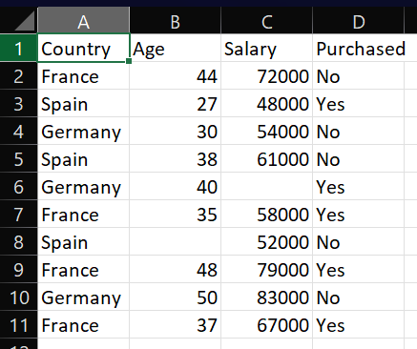

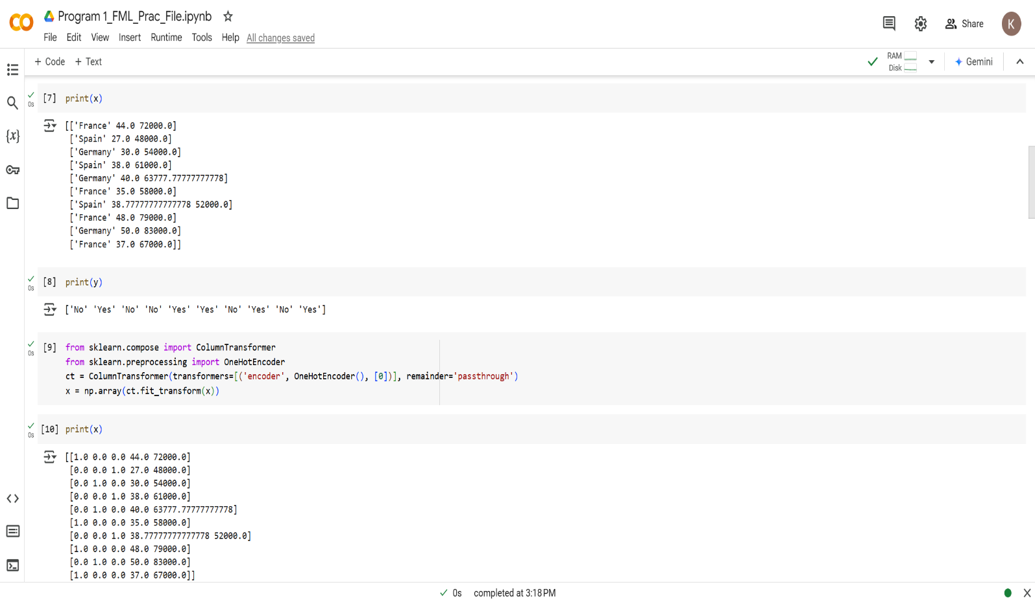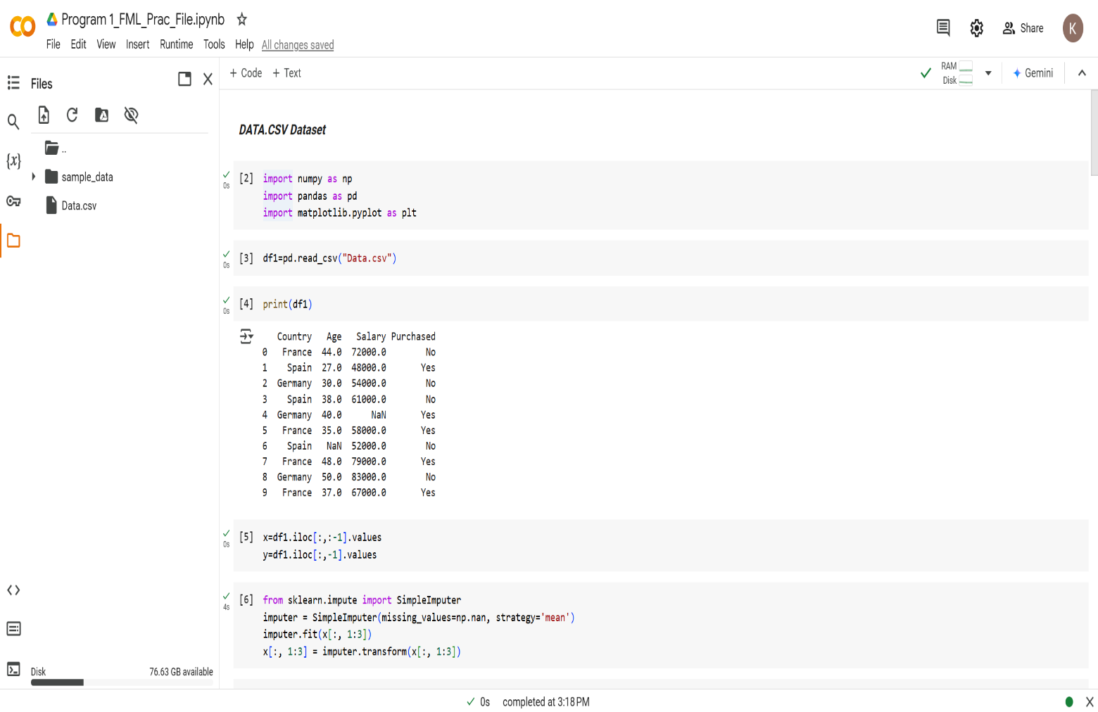**Source Code with Outputs:**

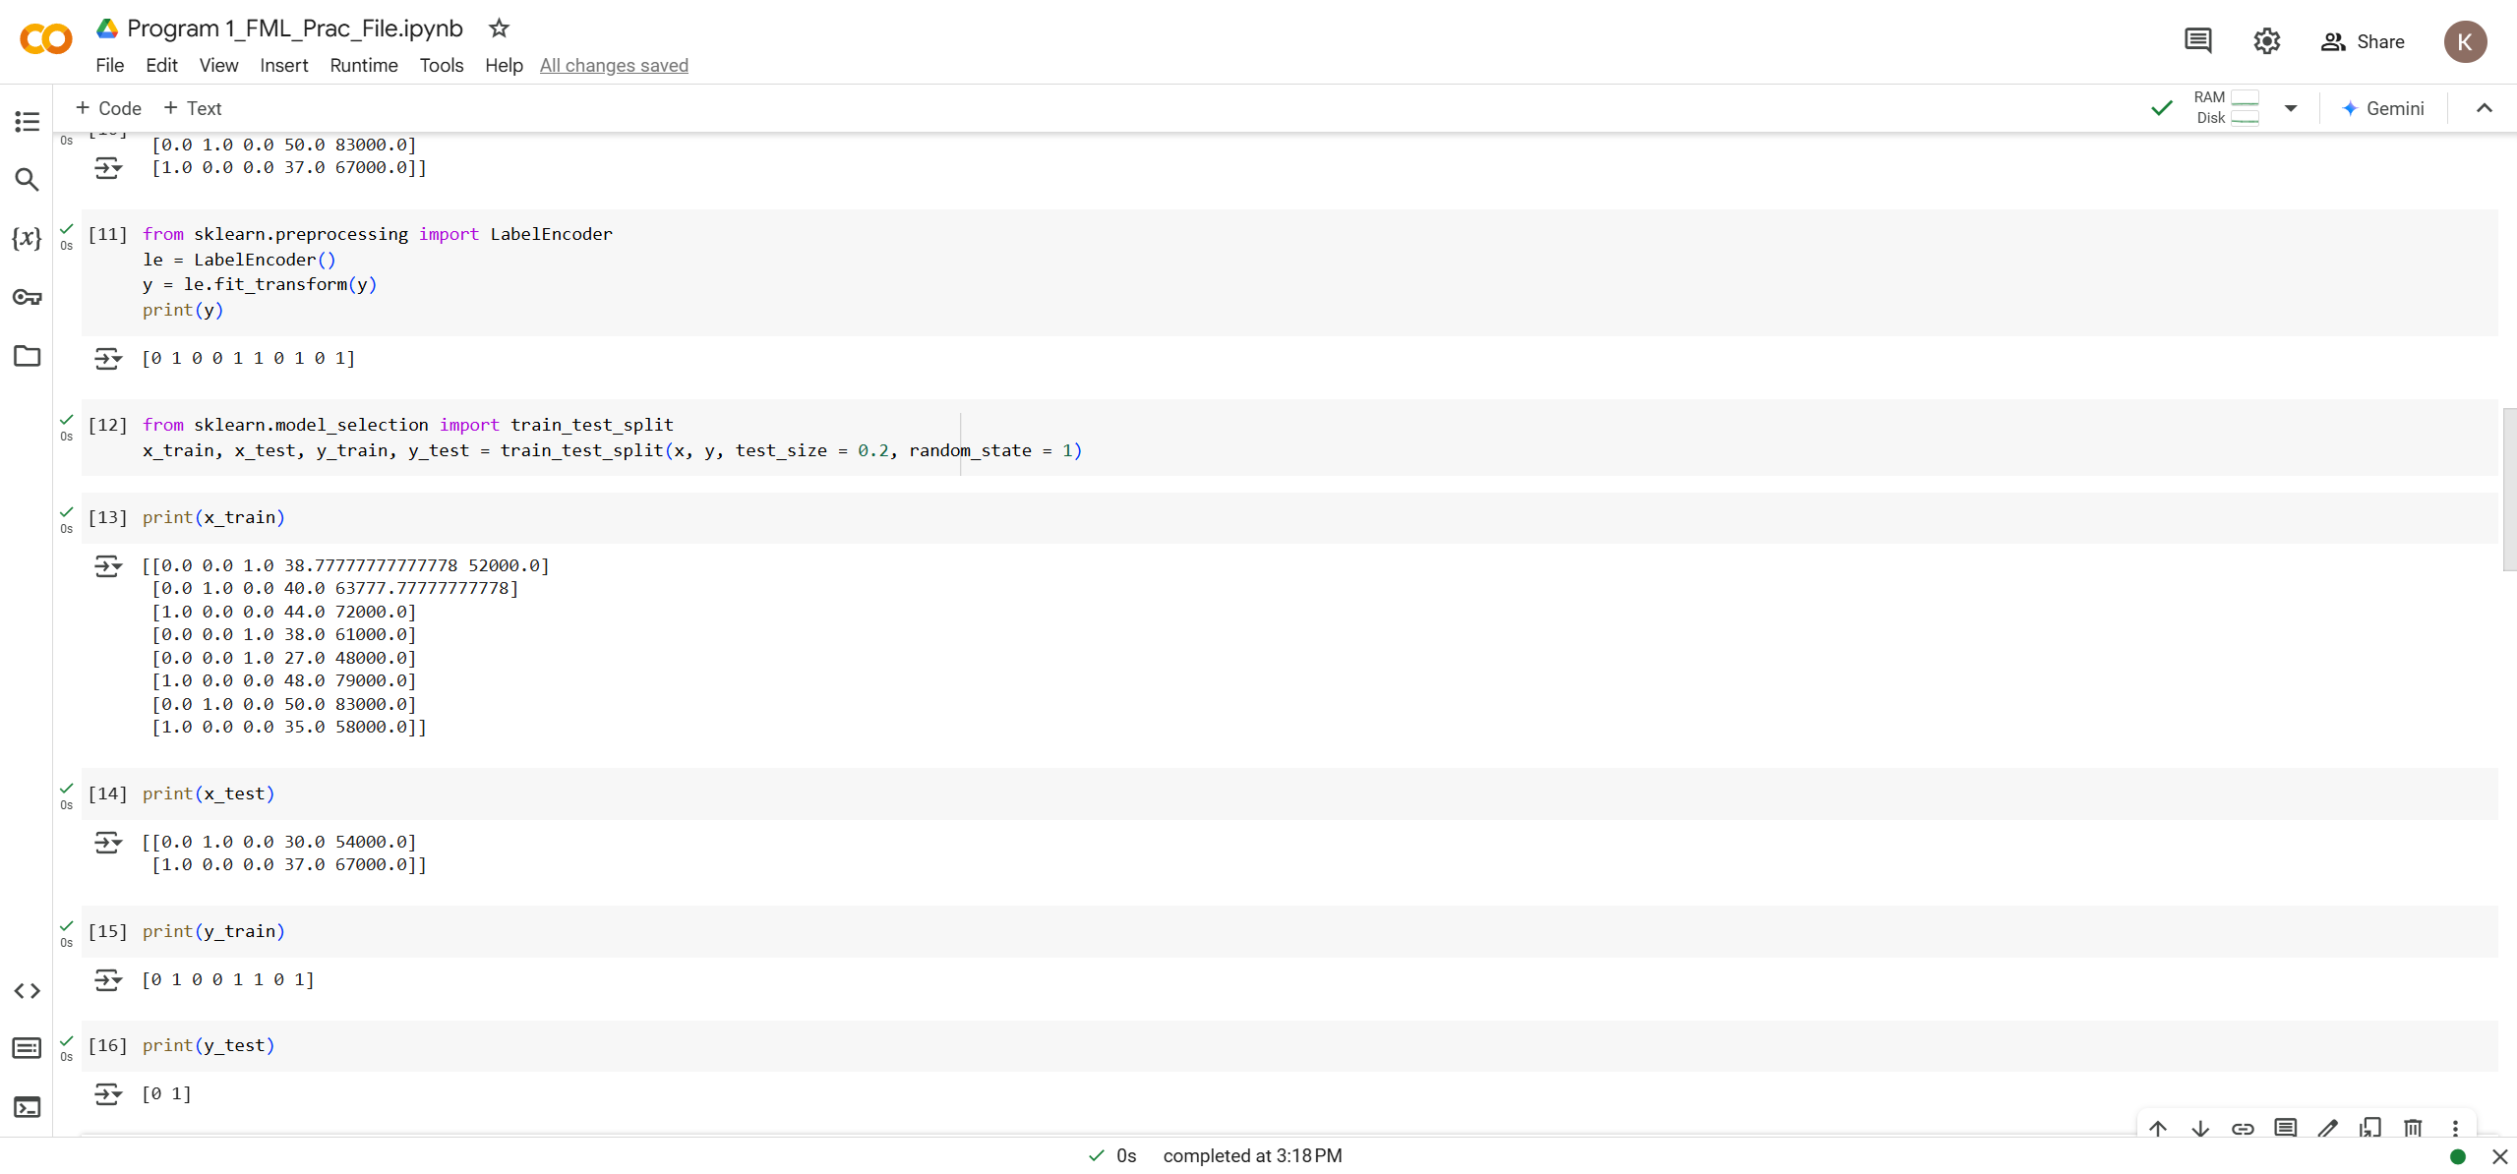**Learning Outcome:**

**EXPERIMENT 1**

**Problem statement:** Study and implement Linear Regression.

**Theory:**

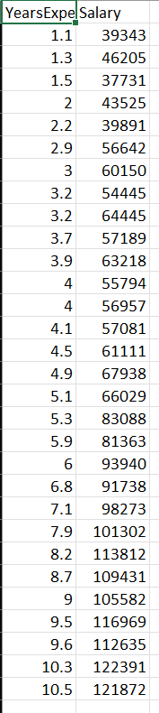

**Dataset:**

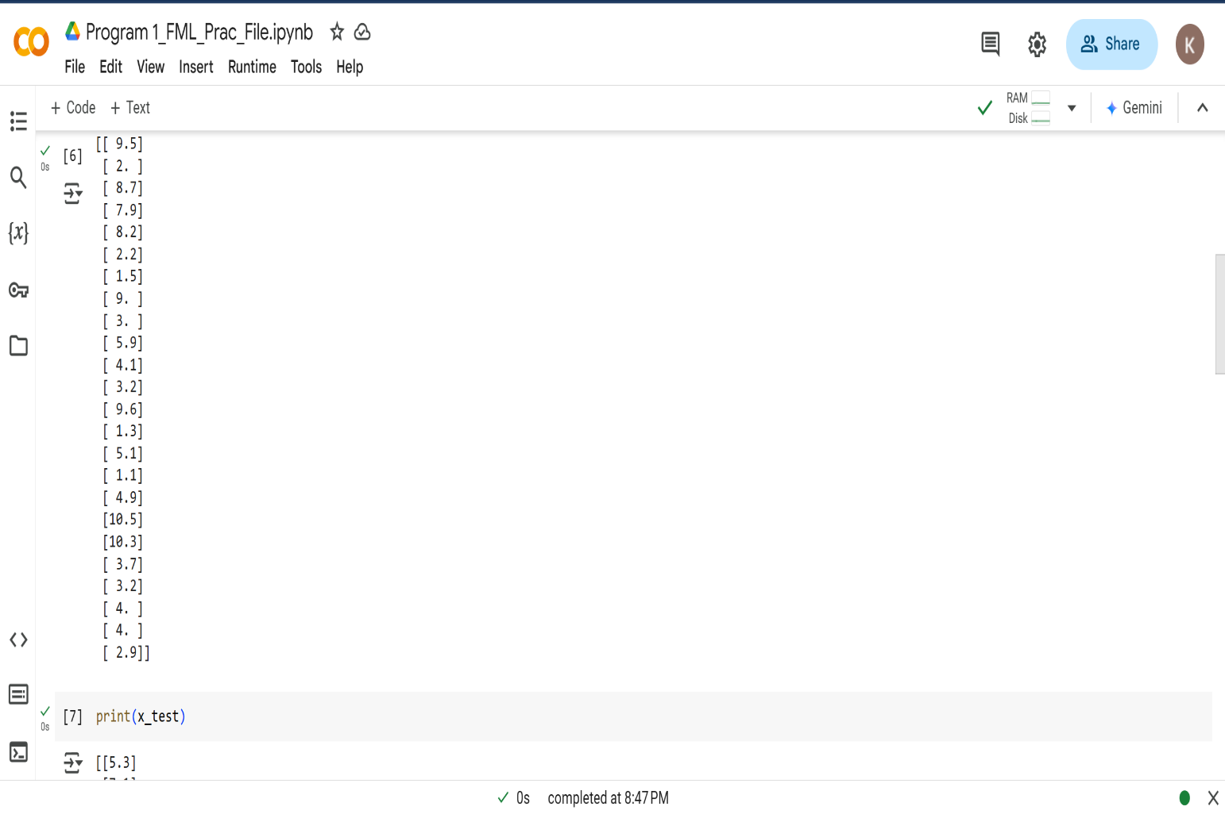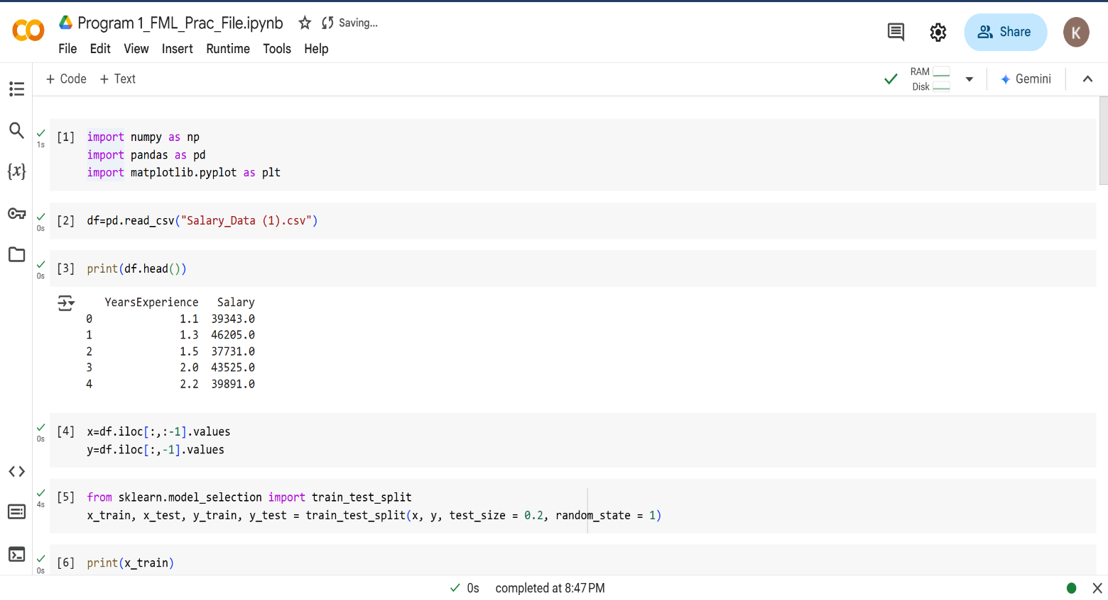**Source Code with Outputs:**

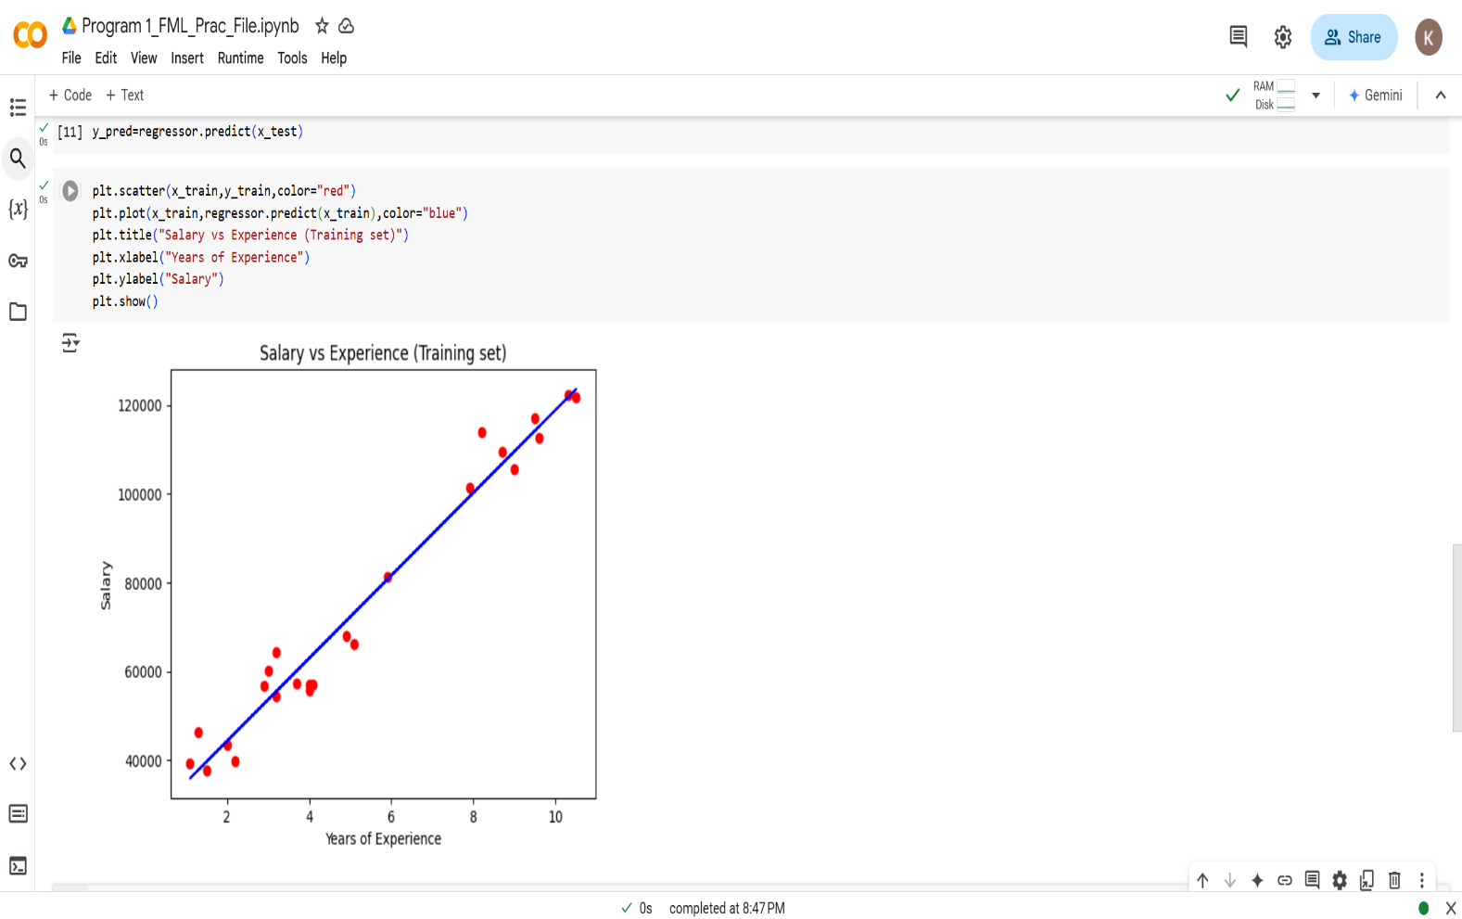 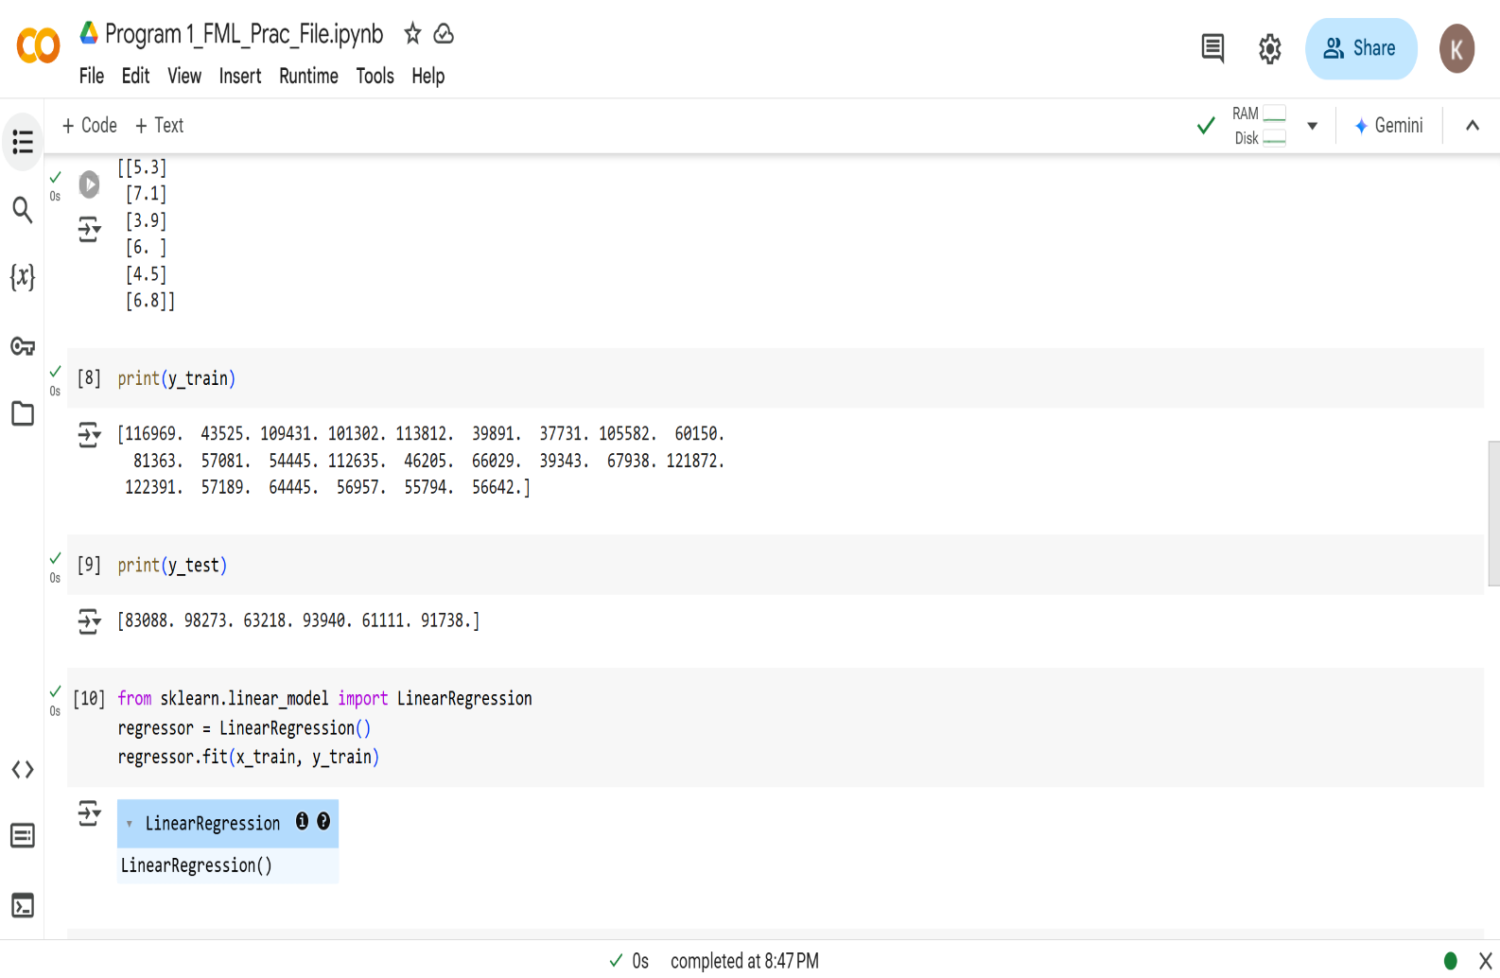

**Learning Outcom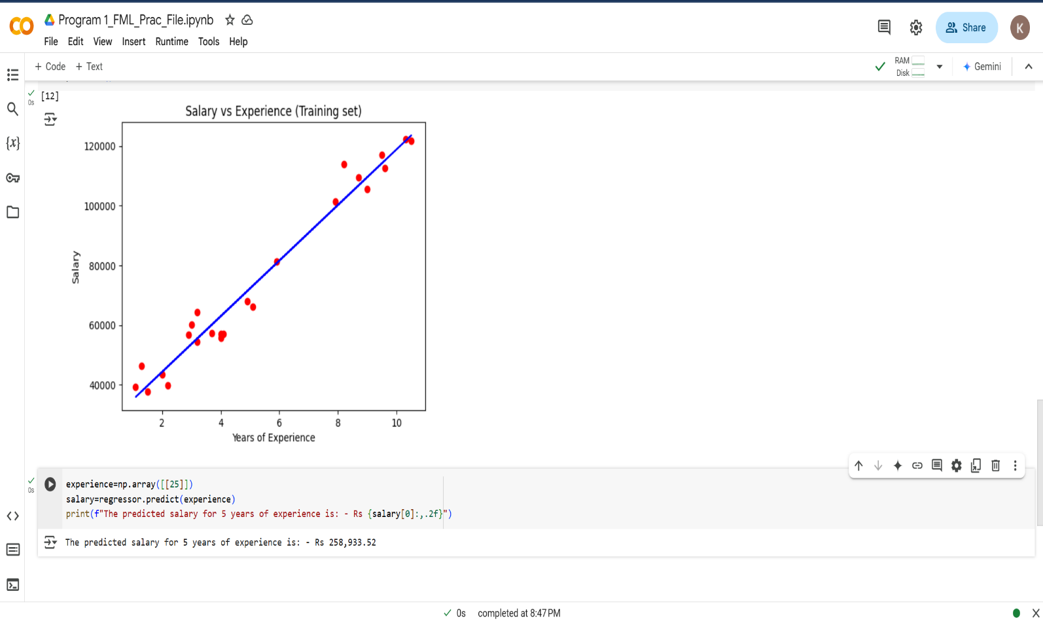e:**

**EXPERIMENT 2**

**Problem statement:** Study and implement Logistic Regression.

**Theory:**

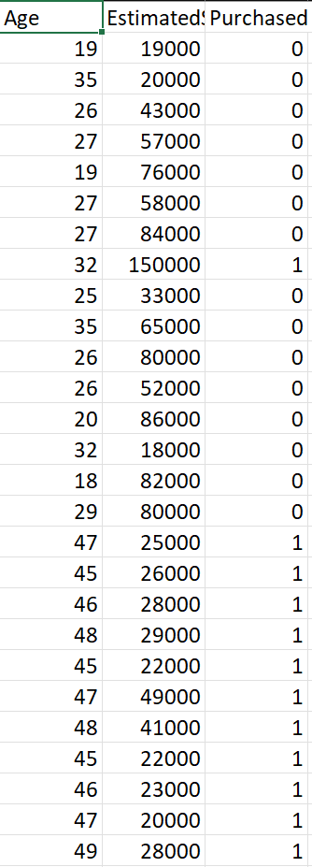

**Dataset:**

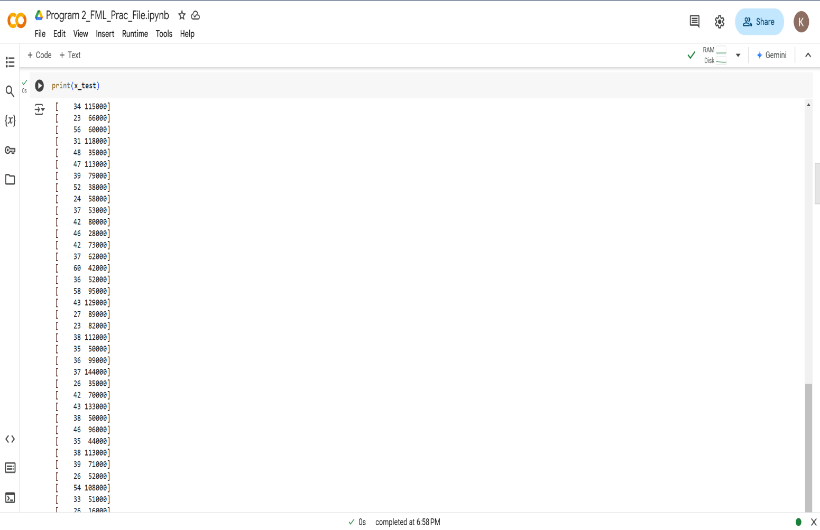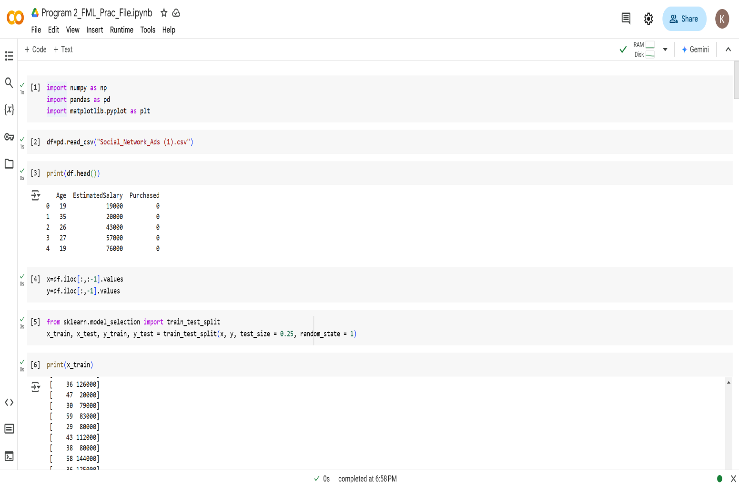

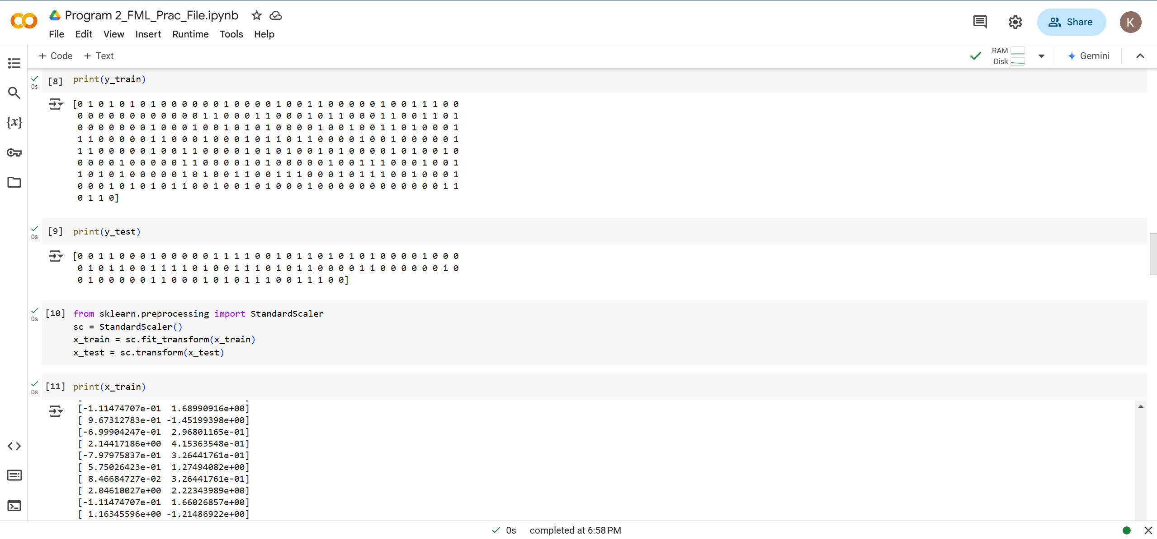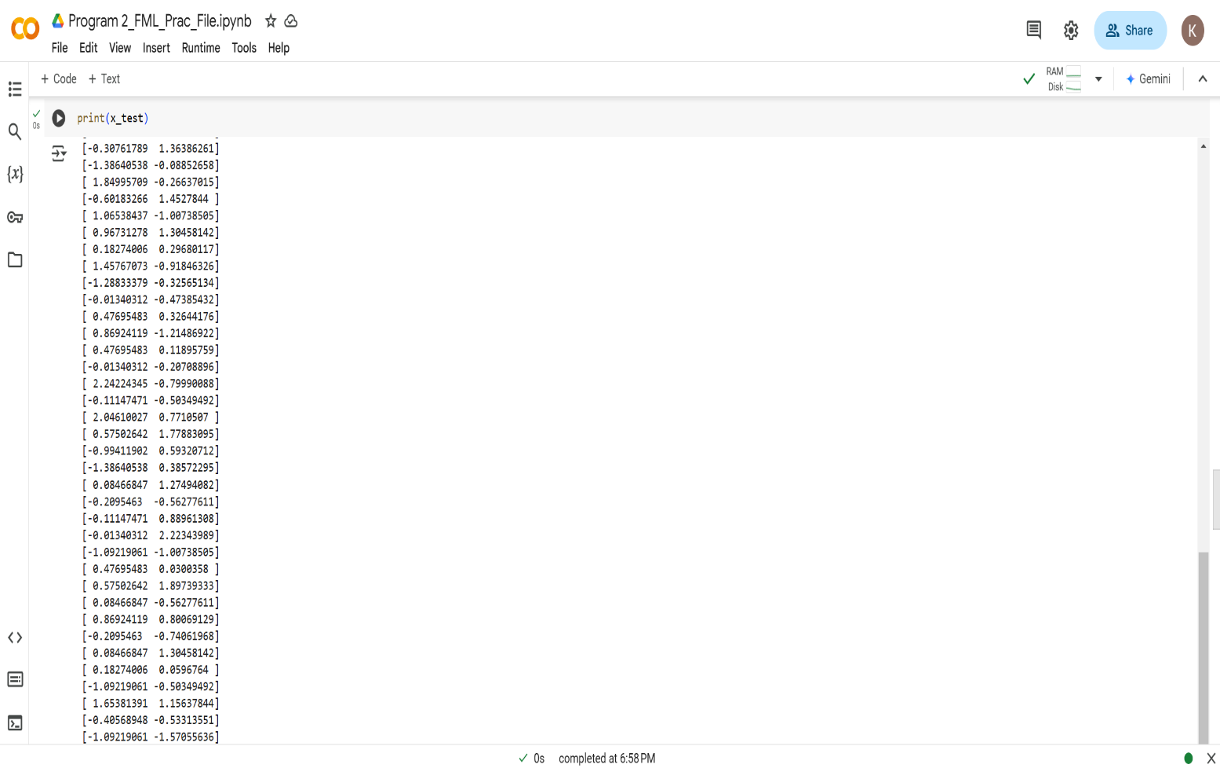

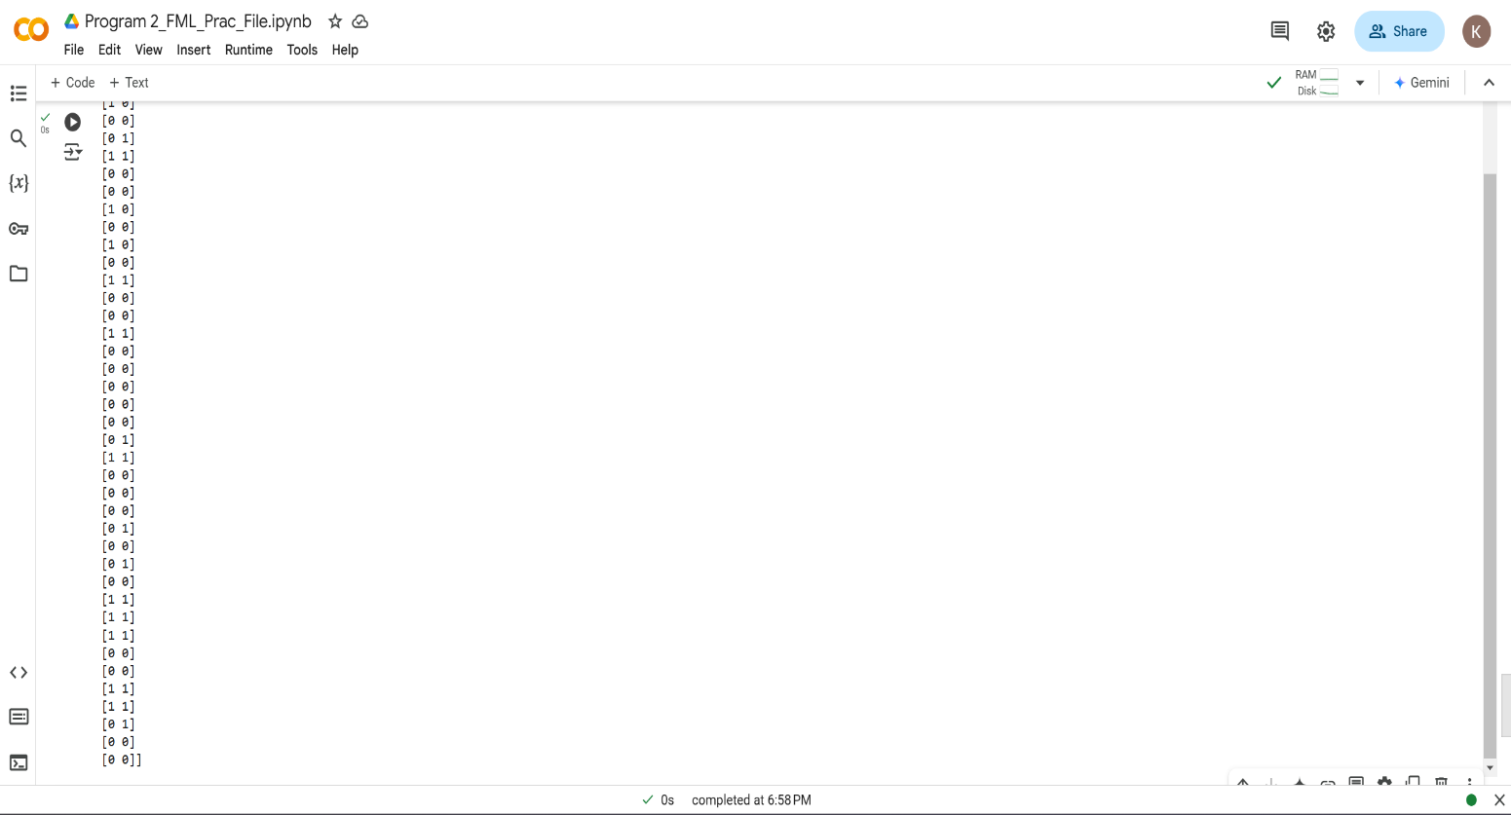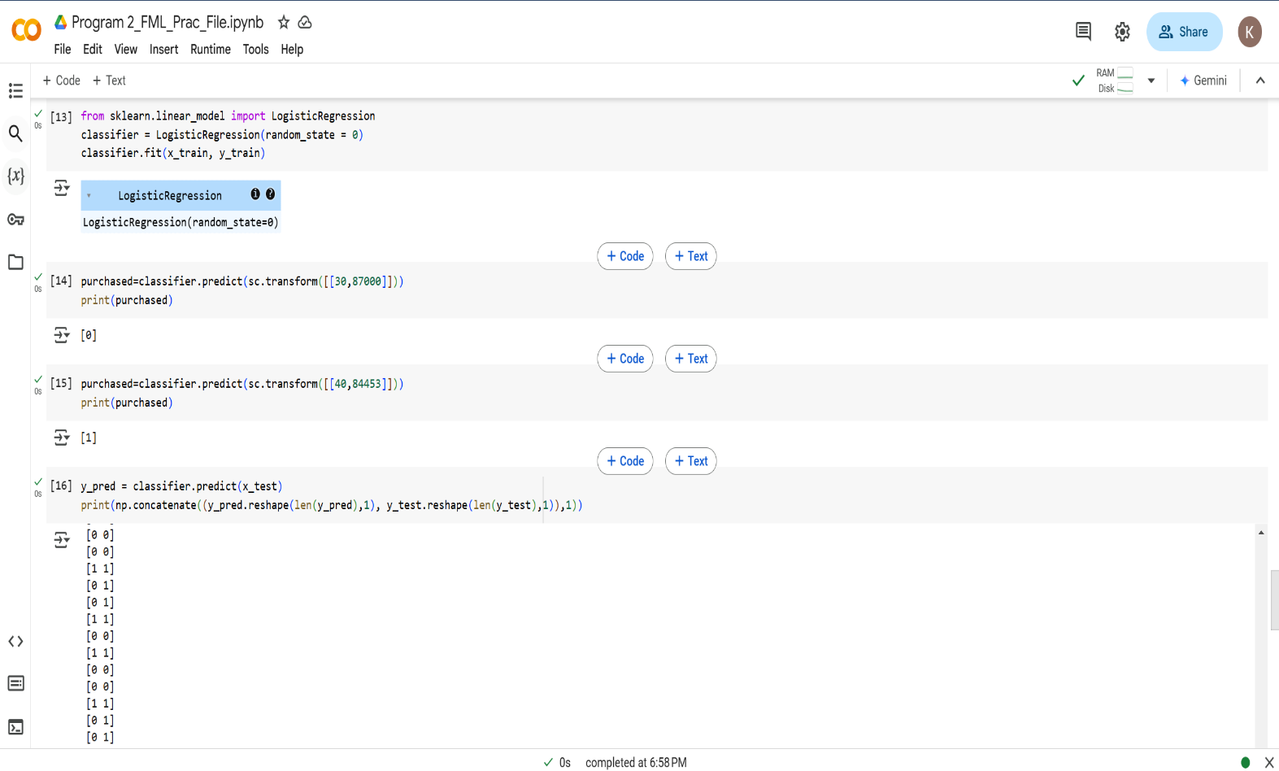**Learning Outcome:**

**EXPERIMENT 3**

**(Beyond Curriculum)**

**Problem statement:** Study and implement Multiple Regression and Polynomial Linear Regression.

**Theory:**

**Datasets:**

1. 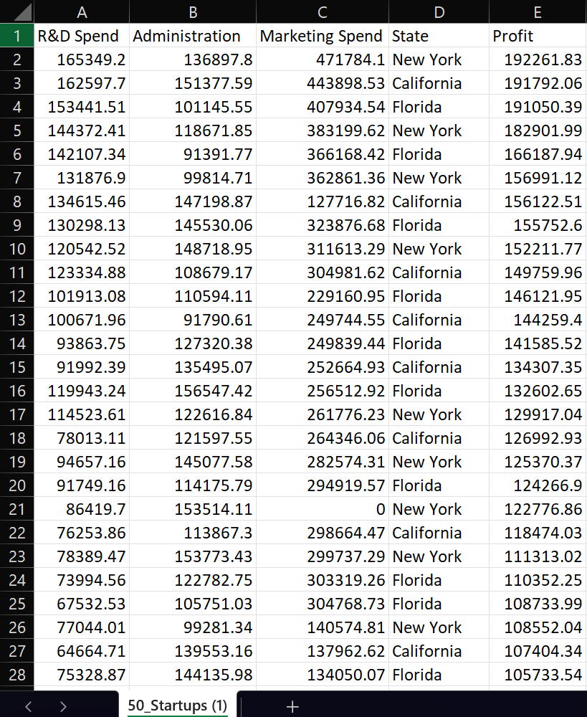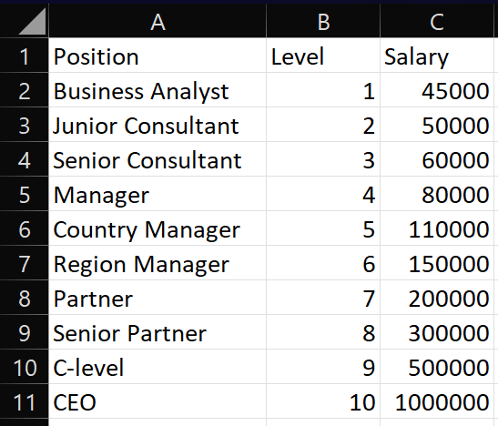50_Startups Dataset 2) Position_Salaries Dataset

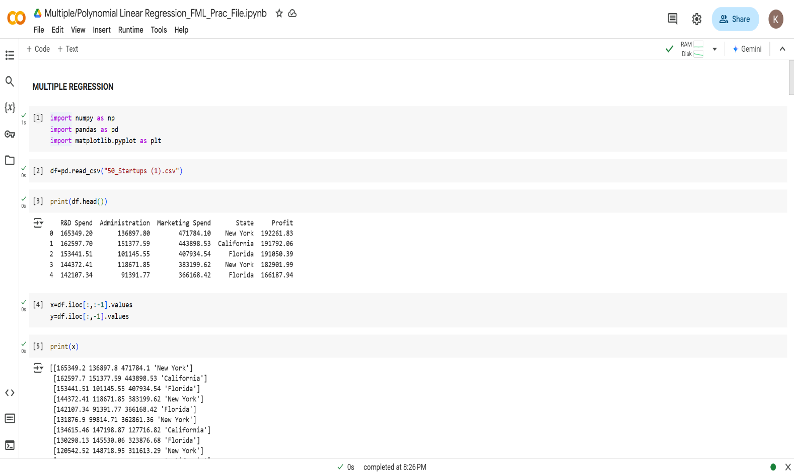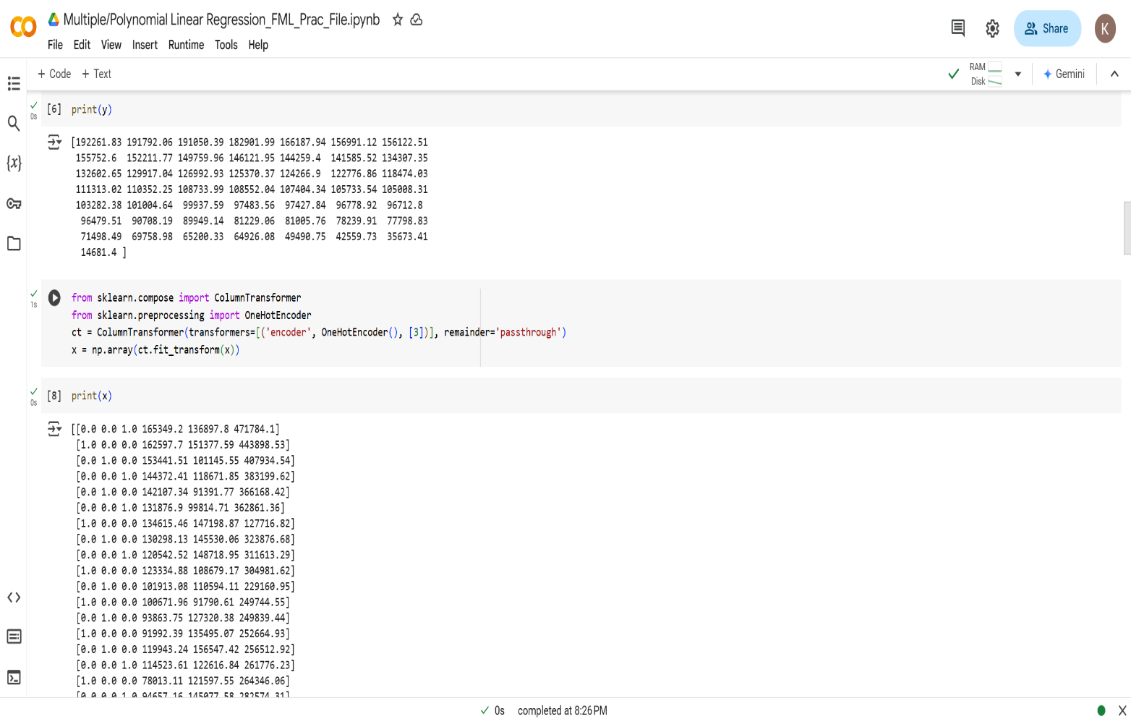**Source Code with Outputs:**

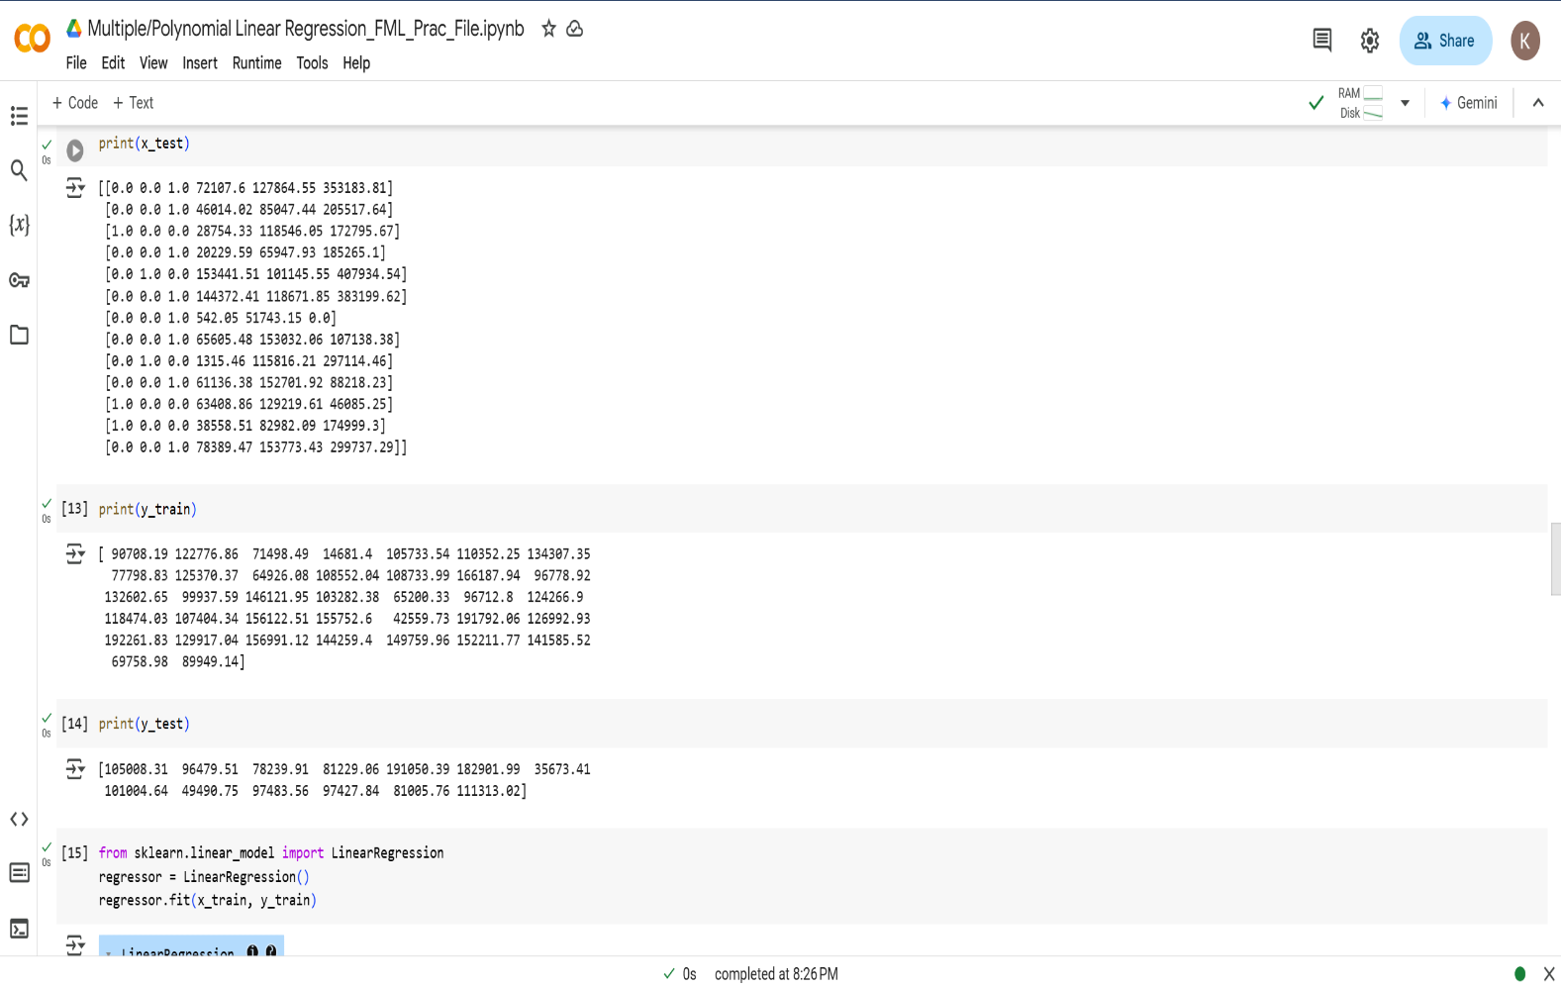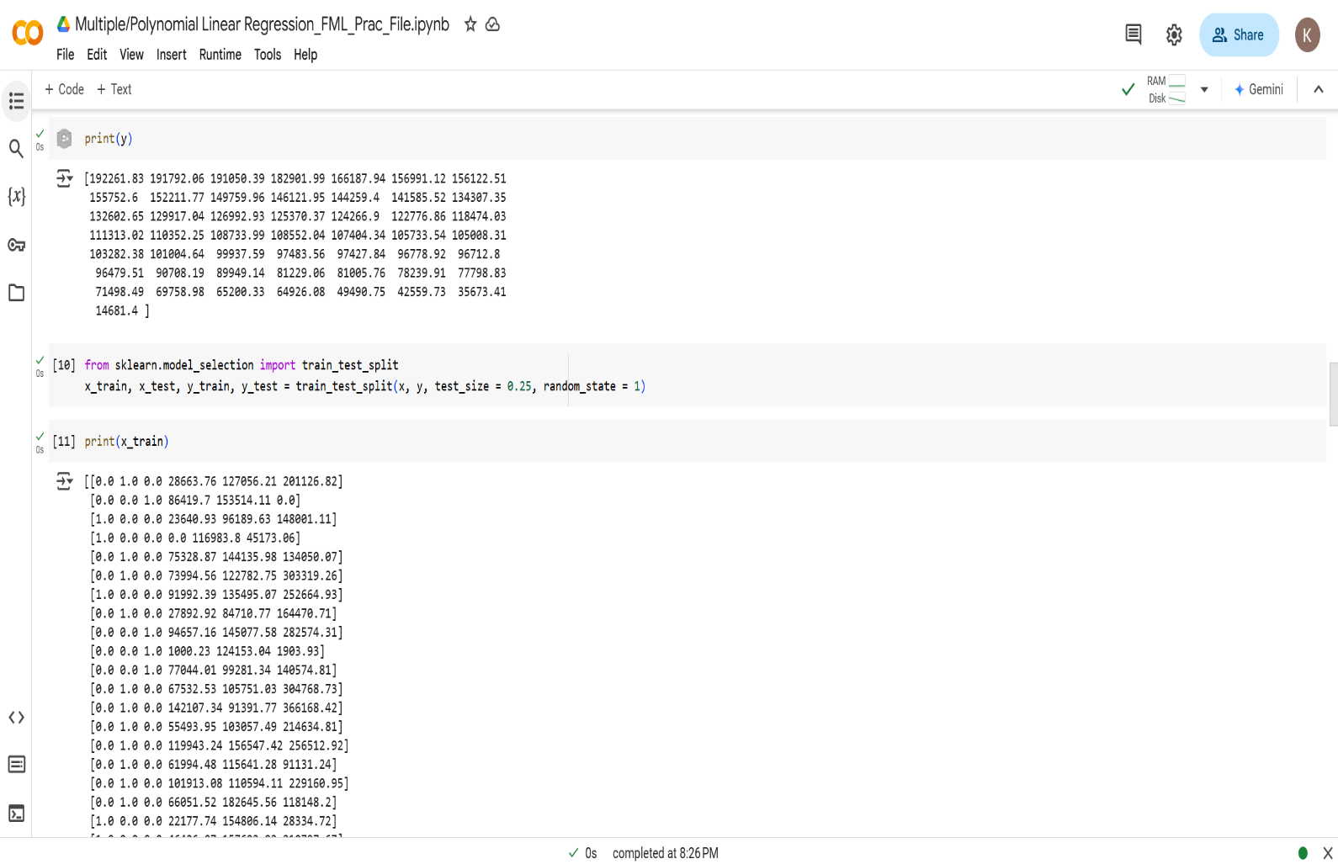

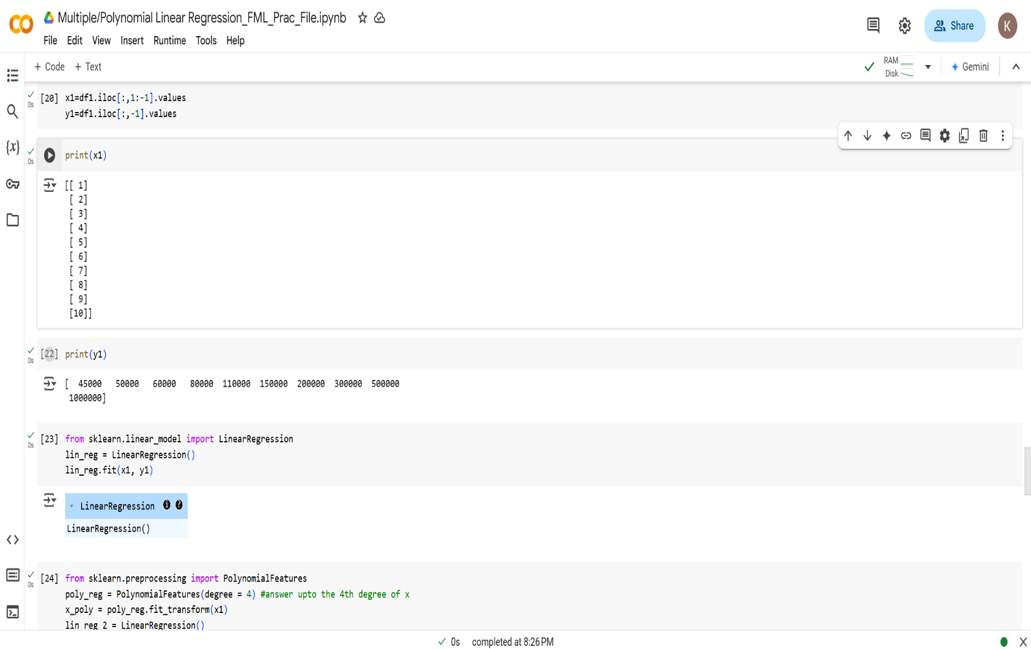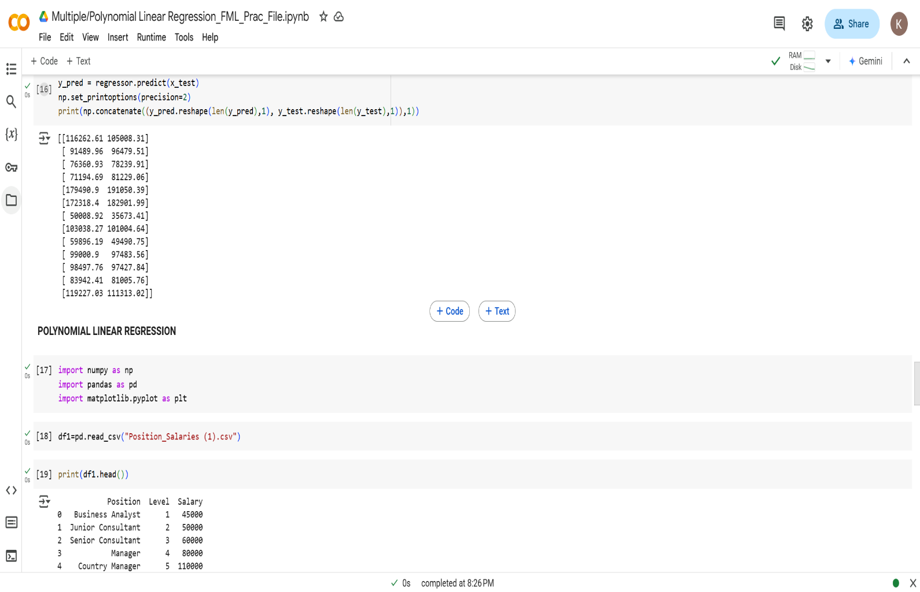

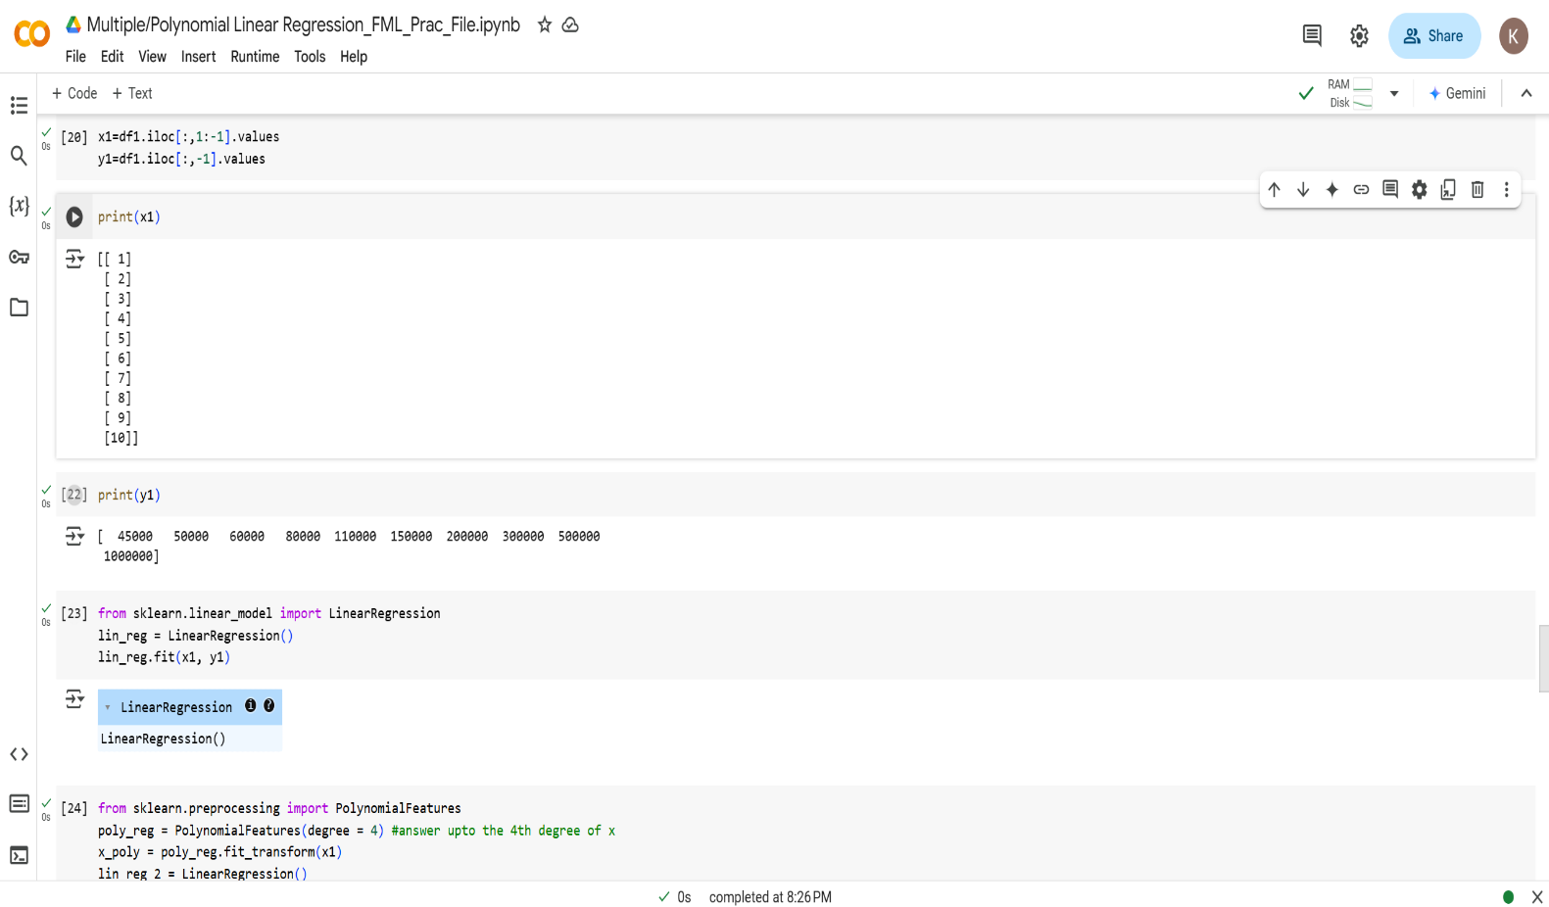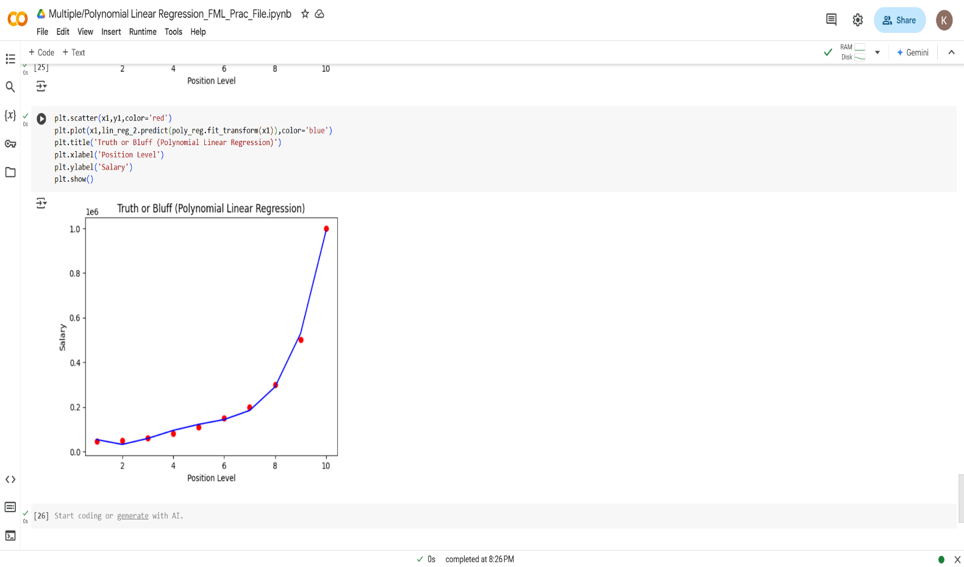**Learning Outcome:**

**EXPERIMENT 3**

**Problem statement:** Study & Implement K-Nearest Neighbour (KNN).

**Theory:**



**Dataset:**

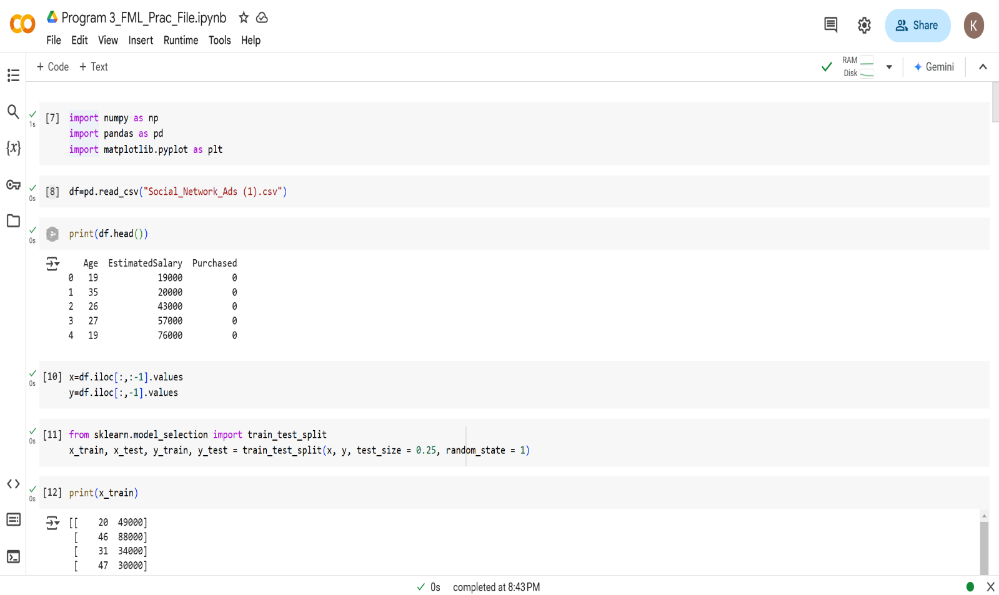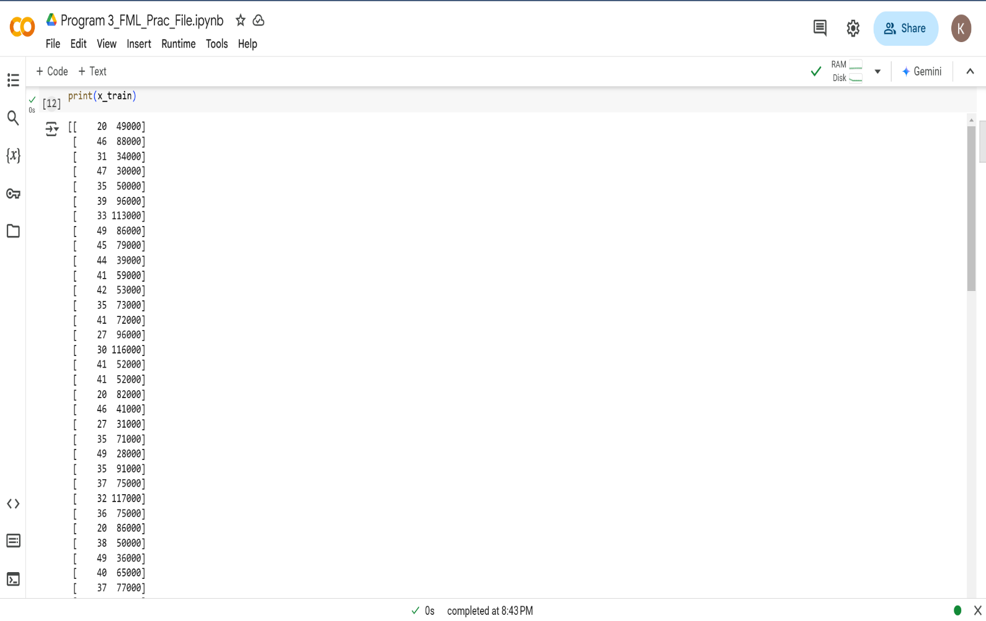**Source Code with Outputs:**

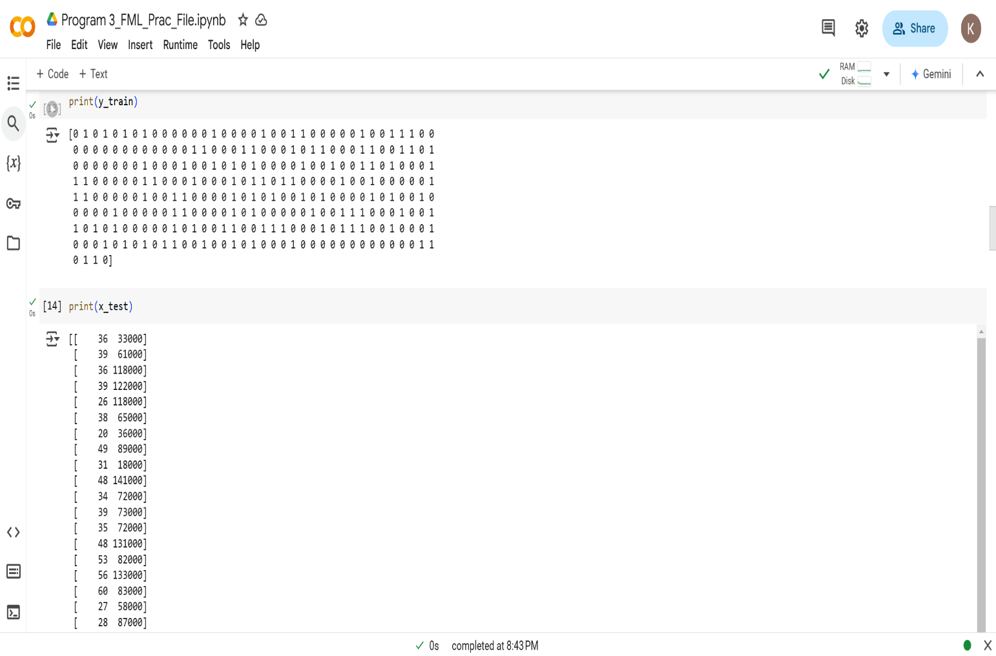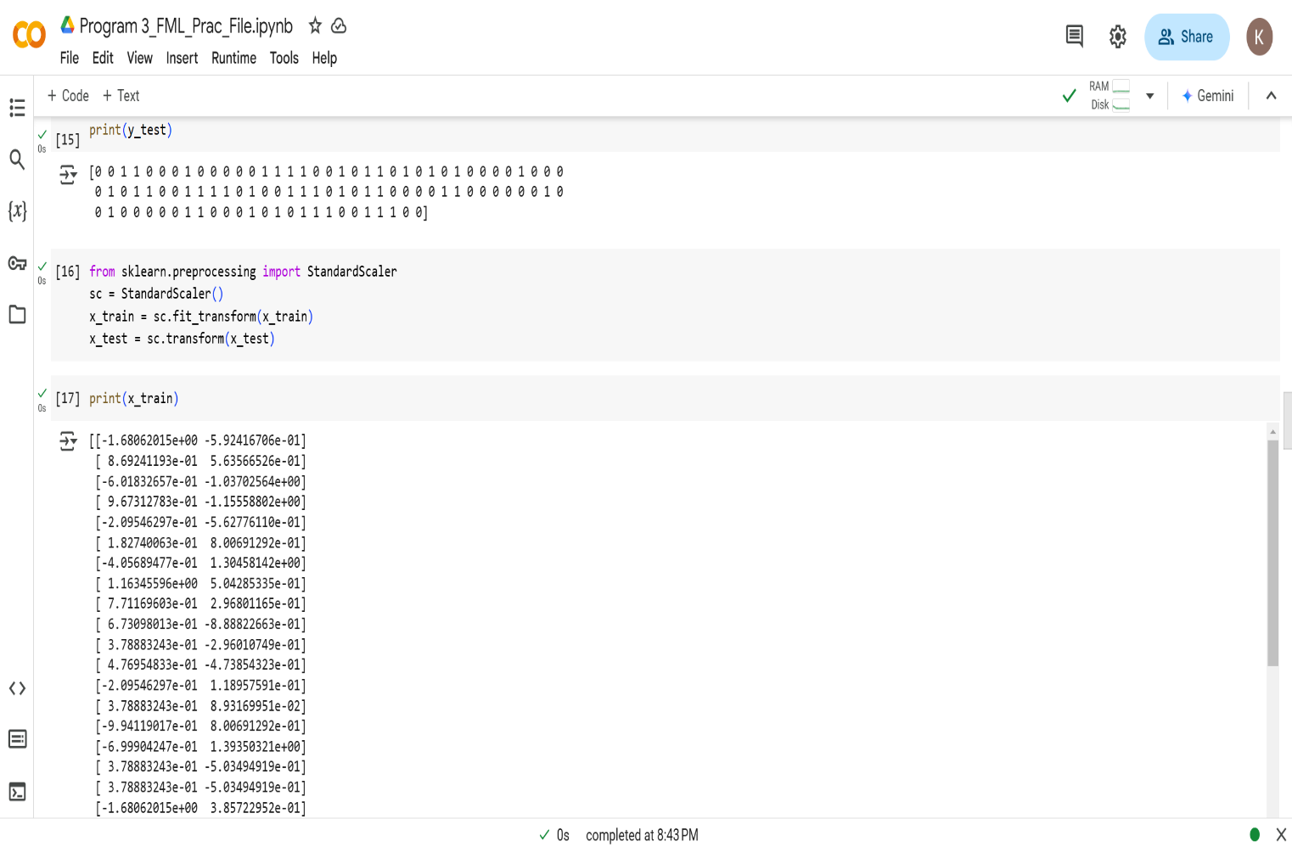

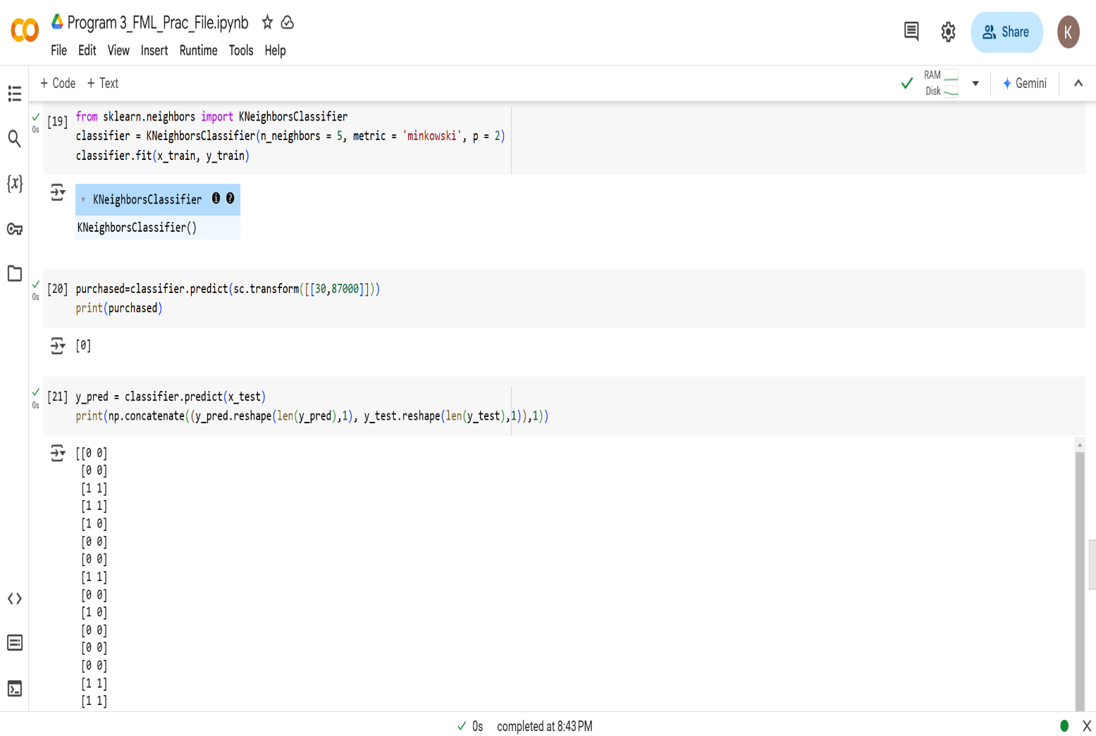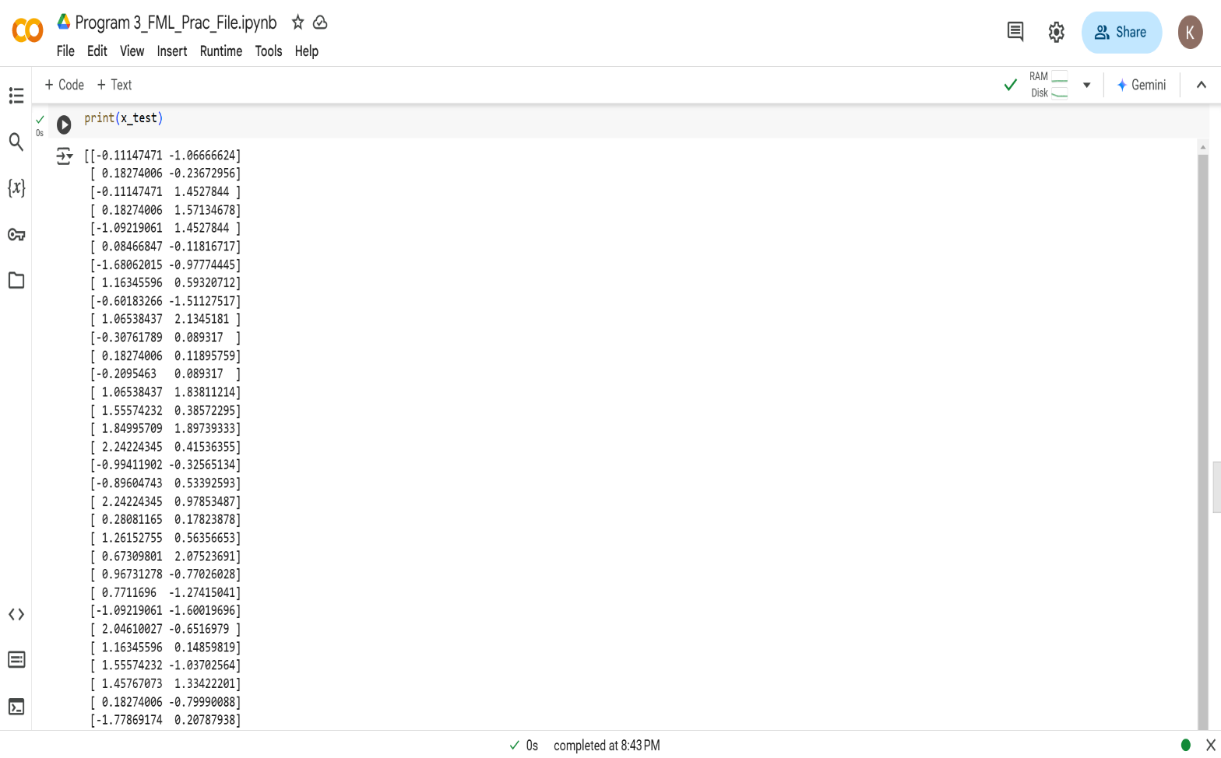

**Learning Outcome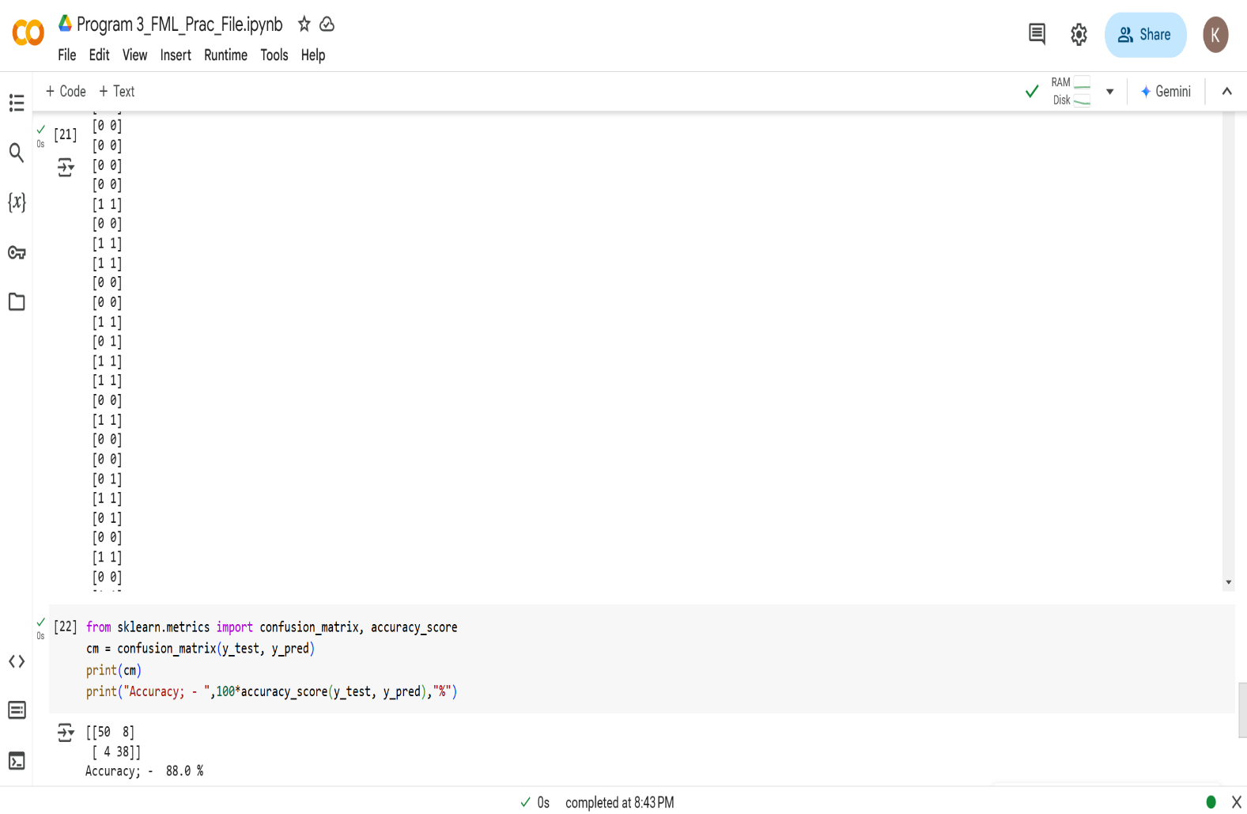:**

**EXPERIMENT 4**

**Problem statement:** Study & Implement classification using SVM.

**Theory:**

**Source Code with Outputs:**

**Learning Outcome:**

**EXPERIMENT 5**

**Problem statement:** Study & Implement Bagging using Random Forests.

**Theory:**

**Source Code:**

**Learning Outcome:**

**EXPERIMENT 6**

**Problem statement:** Study & Implement Naïve-Bayes.

**Theory:**

Source Code with Outputs:**

**Learning Outcome:**

**EXPERIMENT 7**

**Problem statement:** Study & Implement Decision Trees.

**Theory:**

**Source Code with Outputs:**

**Learning Outcome:**

**EXPERIMENT 8**

**Problem statement:** Study & Implement K- Means Clustering to find natural patterns in Data.

**Theory:**

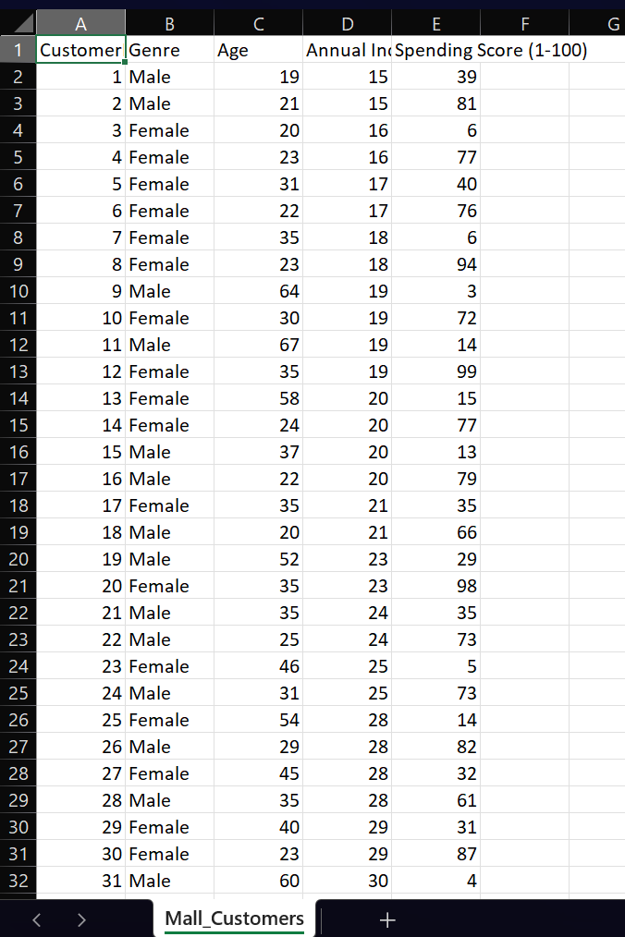**Dataset:**

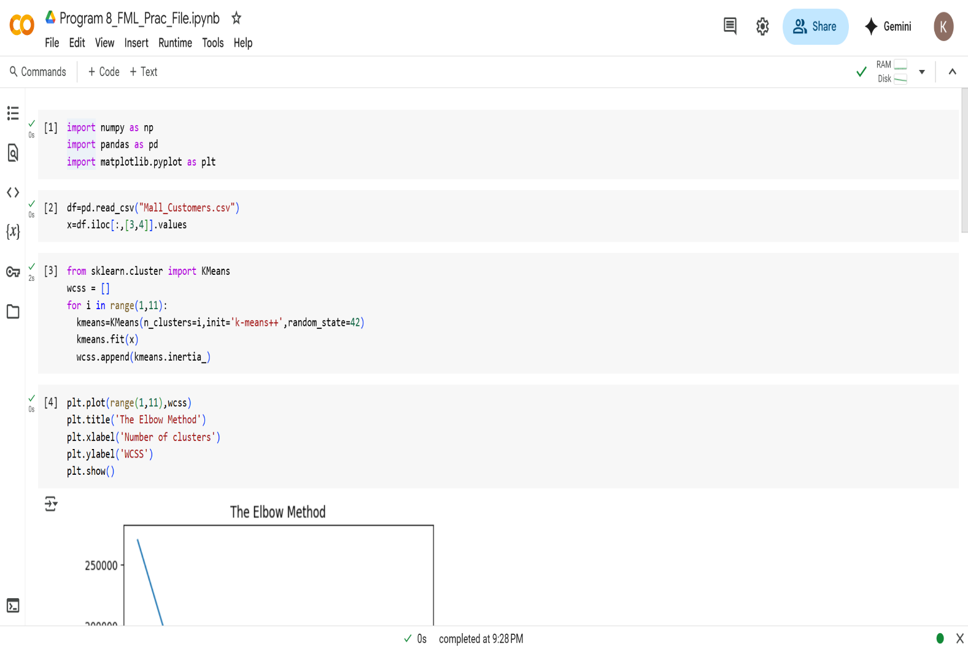**Source Code and Output:**

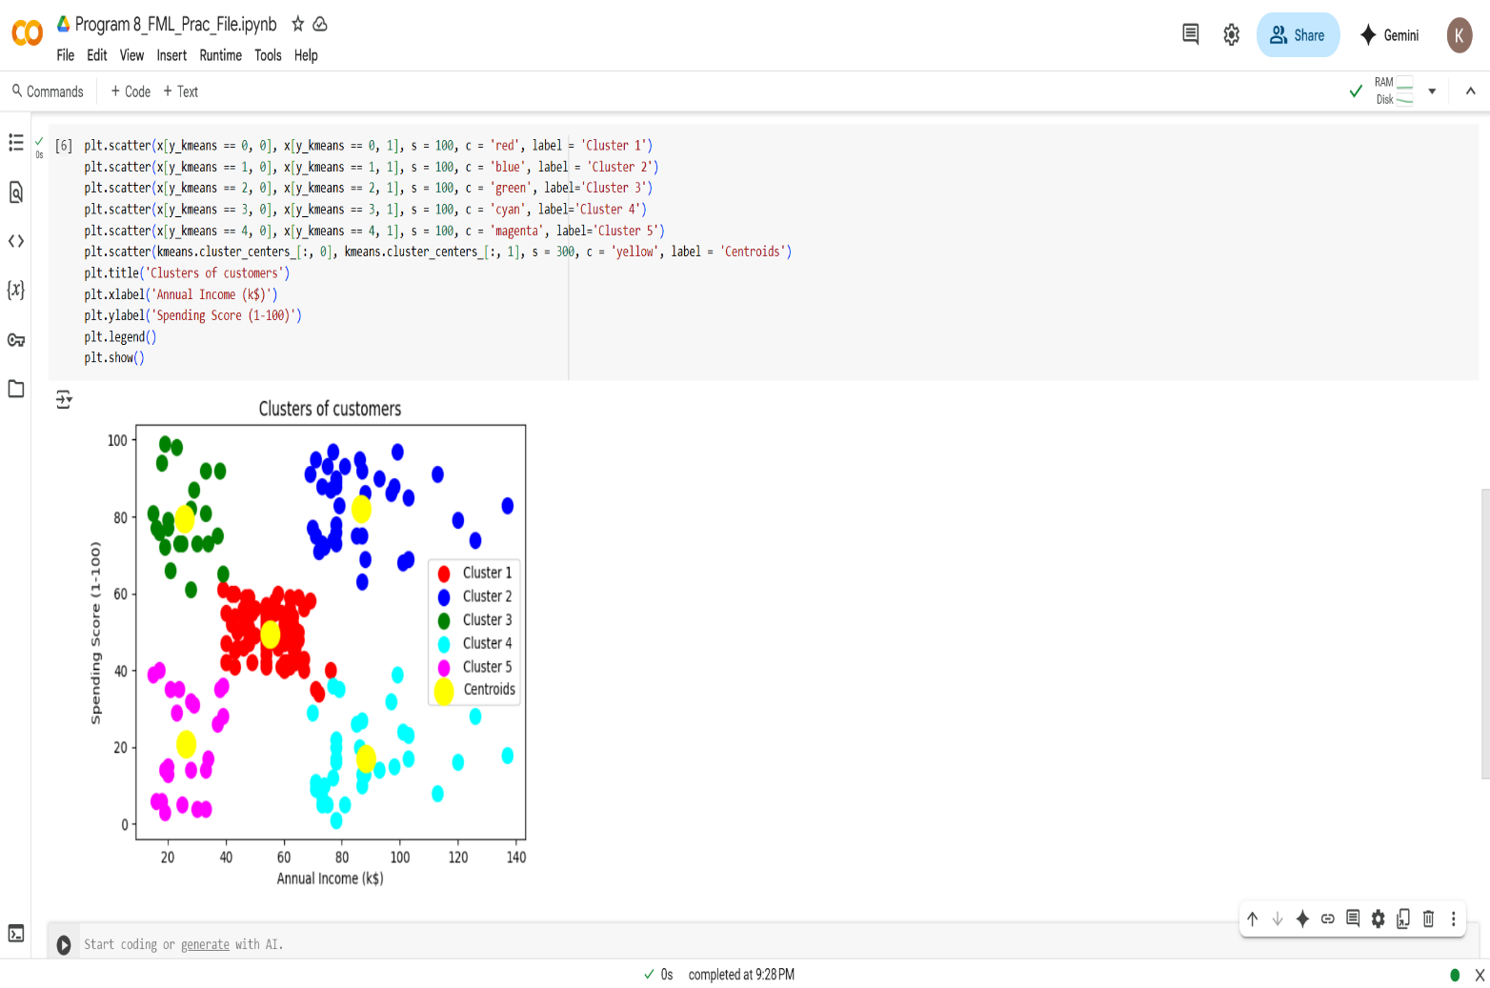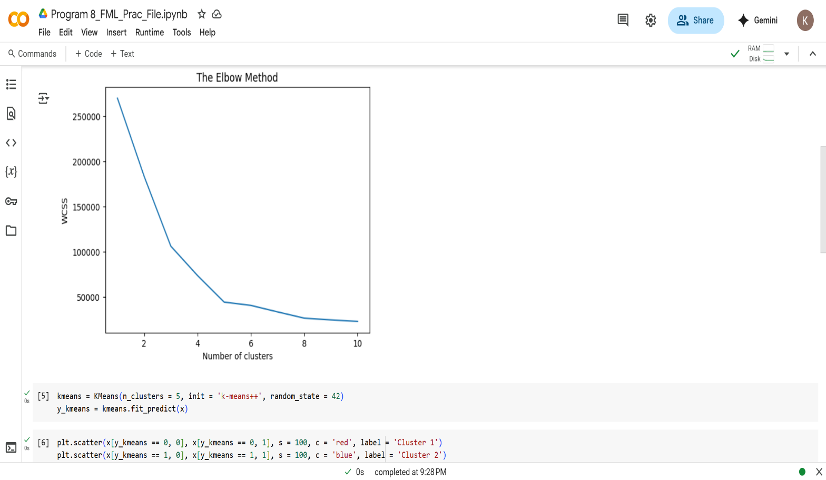 **Learning Outcome:**